From Whence We Came!
Compiled By David E. Bell, FSA Scot
The Border Reivers by Godfrey Watson; Ulster-Scots in Virginia, From Pennsylvania to the Shenandoah, by Richard MacMaster; A History of Everyday Life in Scotland, 1600 to 1800 By Elizabeth A. Foyster, Christopher A. Whatley; John L.B. Bell, Esq.; Wikipedia, bbc.co.uk: "Scotland's forgotten clearances"; Other sources

The 21st century descendants of Scottish families in North America often know little about their ancestors. It might surprise some to learn that most of our Scottish forbearers did not come as casual immigrants to America, Canada or Nova Scotia. Many of us have Scottish ancestors who were among those first colonies’ adventurers. This includes those who, in the 1600s, came directly from Scotland as founding settlers. Later, there was the large influx of ‘Ulster Scots’ (to some, Scotch-Irish) who left Northern Ireland in the 1700s for a variety of reasons. Most have heard of “those 50,000 or so Scots” who journeyed to the New World in chains; most have heard little of the average Scottish family who left or fled their homeland for a life beyond the sea. I believe almost all leaving Scotland were seeking a ‘getaway’ in the strictest sense. Most wanted or needed a new start.

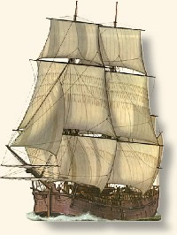
The 17th & 18th century Scots often risked all to take the more-than-arduous- voyage to the New World. They sought land, prosperity and freedoms they had not often found accessible in Scotland, England or Ireland. Despite repetition in some more modern chronicles, all were NOT in dire straits with the law! A goodly number of our ancestors were actually recruited by land agents; others heard hopeful stories of others, family or friends who had been there! Until the 20th Century, getting to North America was possible only by ship. Passage fees were often beyond the means of those wanting to emigrate. Options included having to “sell themselves” into bondage to pay the fare—a fare had to be paid for each man, woman and child, even if one died during the voyage. The voyage (on a ship like that pictured) itself was often a nine to twelve-week “endurance-test” that undoubtedly surpassed all expectations of difficulties to be endured-- especially for those of the poorer class. People often died including soldiers and sailors. They died from disease, starvation, drowning, eating or drinking putrefied/rancid food and water, by suicide and by about every other malady one could imagine. It was not unusual for a family to lose a mother, father or both or a child or children, thus stranding the survivors in near disastrous circumstances. A widow with children or children with no parents would find themselves in threatening and life worsening conditions. This is nearly unfathomable now; it must have been a truly terrifying thought in 1645 or 1720 or 1775.

Why risk so much, leave “hearth, home and kin”, and homeland to voyage to a new life in a dangerous New World?
Scotland and England were frequently at war from the 1200s to the 1700s. “During these wars, the livelihood of the people living on the Borders was devastated by the contending armies. Even when the countries were not at war, tensions remained high; royal authority in both kingdoms was often weak. The uncertainty of existence meant that communities or people kindred to each other would seek security through their own strength and cunning, and improve their livelihoods at their nominal enemies' expense. Loyalty to a feeble or distant monarch and reliance on the effectiveness of the law usually made people a target for depredations rather than conferring any security.” As farmland became more commercialized in Scotland during the 1700s, land was often rented through auctions. This led to an inflation of rents that priced many tenants out of the market and added to the clearances of the Lowlands. “There were other factors that promoted a predatory mode of living. Among them was the existence in the Borders of the inheritance system of gavelkind; estates were divided equally between all sons, so that many people owned insufficient land to maintain themselves. Since much of the border region is mountainous or open moorland, it was generally unsuitable for arable farming but good for grazing. Livestock could be easily rustled, driven back to raiders' territory by mounted reivers who knew the countryside well. The raiders often removed "insight," easily portable household goods or valuables, and took prisoners for ransom.
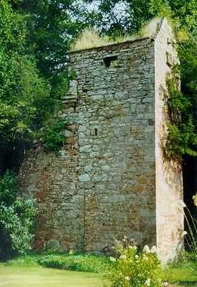
While all Bell (Beal, Beall, Belle, etc.) families did not live in the Border areas of England and Scotland, many did at one time or another. They areas of both side of the border were known as the ‘bateable lands’ or debatable lands. Interestingly, the border families, including the Bells often fought in support of the respective kings of the different countries. In the late 1500s and early 1600s, the chief of family/clan Bell lived in the West Marches in the Dumfries and Middlebie areas of Scotland. . (http://www.gatehouse-gazetteer.info/AP/yeBlacketthowse.html) His residence was a peel (pele) tower known variously as Blackwood Tower, Blackwood House, Blackett House, Blacketthowse and Blacket House. “John Bell of Blackwoodhouse is on record in 1459 and 1465, the Bell family having settled near Middlebie at the beginning of the 15th century.
The first Blacket House was destroyed by the English in 1547.

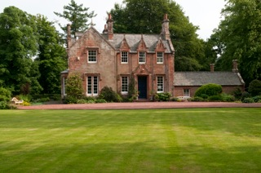
The newer and existing Tower appears to date from the second half of the 16th century; William 'Red-Cloak' Bell is documented as being of 'Blacathous' in 1583/4. Its situation provides commanding views along the Kirtle Water from Old Kirkconnel to Wyseby and Bonshaw, which allowed the Bells to keep a watchful eye on their Irving and Graham neighbors. The tower is depicted on the Aglionby's Platte as 'Ye Blacketthowse' in 1590, and on the Pont map as 'Black-wood hous' in c.1595-96.” For those who have seen modern pictures of the Blacket House Estate , the pele tower was far less glamorous but vastly more functional for housing your cattle, valued horses, some sheep and your family when a “rode” (raid) was underway by a ‘murdering & thieving neighbor’.

Built of stone, the pele or peel tower was less likely to be burned down during such a raid. Raids occurred with such frequency that a system of warning fires and signals was developed and implemented all along the Border. The tower was where the clan chief or ‘hedesman’ could flee during a raid – he, his family and his stock had a higher prospect of survival in this tower than did many of his kinfolk and allies living in the Marches. “Smoking them out” was an often attempted and an effective tactic of the attackers.

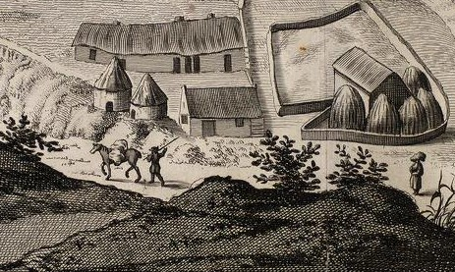
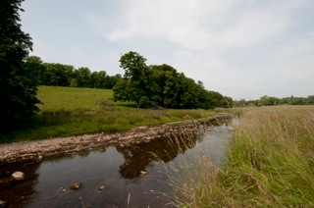
The tower was located near the Kirtle River. Opposite is a Lowlands farm of the 1690s depicted in Wikipedia. Life was difficult, though usually better for the chief or hedesman and his close family though the hedesman did work to make life better for the others allied with him. And they had to work together to defend their homes and property. As Godfrey Watson notes, “Border history is full of stories of towns being burnt down; usually by reivers but often on the instructions of a warden. (e.g. border sheriff & peacekeeper?) “Ding down the nests and the rooks’ll flee away.” “But the rooks did not fly away; they waited for their assailants to depart, and then rebuilt.” A Scottish historian of one such raid found that the very next day, “they make (an)other; they did not remove from the ground, so wretchedly could they live and endure the pain no Englishman could suffer the like.” However, “those on the south side of the border (in England) suffered in much the same manner….”

So Bells, like other families on both sides of the border suffered much of the same. These were tough times; tough people!
Regardless of the style of home, the border families often found them destroyed… in a raid if not by a war. Godfrey Watson in his study reports that it took the reiver families about three to four hours to re-build their homes. How? First they dug holes into which they inserted tall wooden stakes. With the addition of stones, dirt and turf to fill the gaps, basic walls were formed. Brush wood and twigs were woven around the stakes to form a wall; mud or clay known as ‘cat and clay’ was plastered over all to dress out a finished wall. Larger branches were then laid across walls to form the base of a roof. Heather thatch (sometimes sod) was added to finish the roof. A smoke hole was cut in the roof so it would escape. Windows, if they existed, were unglazed; most often they had wood shutters that were used in foul weather or at night. ‘The door was usually made of cowhide.’ Building anything more durable and costly was a waste of time as the next raid would see that house destroyed, too. If the house took longer than a few hours to build, the family could easily be subjected to death by exposure. Clay homes, and sod shanties were the standard for most. Whole towns on the borders were described as “the most beggarly town of sods that was made in an afternoon of loam and sticks.”

Better houses had half a wall of stone that was then completed in the same manner as described above. For the laird, “hedesman” or chief, there was a nicer home, possibly all stone, and the protection of the tower or castle. Bu the tower was not a complete escape from danger; raiders would try to burn or knock down all structures: rock towers, homes of rock or of sod and strong oaks hewed square. Raiders were there to steal cattle, sheep, and goods. “The possession of a tower did not, of course, remove the risk of fire to which other dwellings were subject: it only reduced it, and various methods were tried in order to lessen the danger.” The home or tower of the laird/hedesman/chief was usually more luxuriously appointed and more comfortable. But their luxury was not our concept of luxury; fearing fire they usually had little wooden furniture but rather, stone benches, etc. Luxury would have been blankets, cushions, pillows, and tablecloths but little else of “luxury”. In the multi-story tower, livestock resided on the first floor, the family on the floors above them. Cow and sheep dung and cook fire smoke were common smells, probably ‘homely and comforting’ smells to our ancestors. In the winter, the animals, in addition to being food and drink, gave off much needed “free” heat that warmed all.
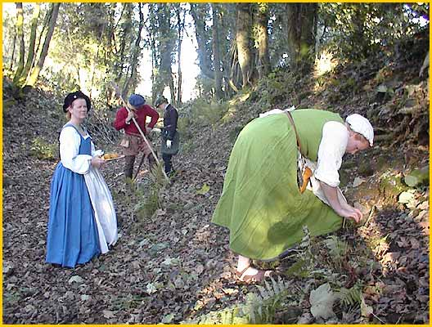
Food was basic survival victuals—plain and boring by almost any standard but food. Oats and oatmeal were the mainstays of the Lowland/Border family. Foyster and Whatley report that, at the end of the seventeenth century, the average male needed to consume 37 ounces of oats (in some form) a day to do a day’s work. The oats were served as oatmeal, porridge, brose and in oatcakes. Fully half of the Lowlanders’ diet was grain-based with peas, beans and cabbage supplemented, when available, with butter, cheese and milk. Sheep and beef were occasionally on the table as were pork and rabbit (both hunted and family raised). The average borderer never saw much bread, never white bread; the lairds had both brown and white bread on occasion. Red Cloak hunt deer in the Cheviots, other beasts and fowl (pheasant was of often seen hanging in the meat shop) added more variety. The water ways provided some fish, especially herring, fresh water muscles and waterfowl. Potatoes were unheard of until the late 1700s. John L.B. (of Blackethouse) Bell’s ggggreat uncle George Bell, of Woodhouselee, was noted for his skill in raising turnips and other fresh vegetables. Markets were available in cities, especially those on the coast. Fruits, a variety of vegetables, and olives were available imports. The more affluent were more likely to “shop” at these markets. While wardens/sheriffs often called for the burning of all owned by unruly clans including storage bins of grains—barley, oats, etc, it is reported that many reivers often rejected destroying this last ditch and only hope of life—they would not want raiders doing the same to their families. Death by starvation was an undesirable, uninvited guest that often knocked at the door. Between 1604 and 1755, there were at least 20 separate years of acute famine in Scotland—the Lowlands experienced extremely severe starvation in some of those years. John Bell reports the story of a Dumfries-shire man found dead of starvation with grass in his mouth. Though all were impacted, children were the most threatened by poor nutrition. As to drink, water was the usual drink; wine was not generally available to the average man but would have been to a clan hedesman. I am assured that penny beer could always be found and drunkenness aided the occasional man’s downfall, to include murder by one George Bell, of Blacket House, while drunk. One John Bell is noted as having become known as John Bell, the Bender, because of his excessive drinking. Penny Beer!

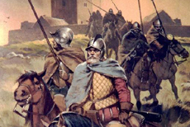
As for eating when on a “rode”, the reivers carried no pots and pans. They carried a metal plate and a bag of oats on the backside of the saddle. They heated oats, barley with whatever else they had on the pan. They would slaughter a beast, if pursuit time permitted, eat it with the oatmeal that might also be mixed with a few peas, beans, or tallow and often formed into a small cake.

THIS is but a smattering of how many of our ancestors lived for last 300-400 years they lived in Scotland! Border families were the bulk of those forced into the Northern Ireland plantations. The forced re-location (clearance) was often accompanied by the promise of a new life with land ownership possibilities, if they helped build a woolen, linen and other industries. Land promised rarely was obtained; wool and linen were to be sold only to the English rather than on the world market! While many Bells remained in Northern Ireland, many left. In 1700, there were about 7500 Scots (3% of the Population) in America. By 1750, with the population greatly swollen by the migration of “Ulster” Scots to America, the total rose to 11% of the American population. Most entered America by travelling up the Delaware River to Philadelphia or sites in Delaware. From there, they headed into Lancaster County, Pennsylvania and further west toward Carlisle and Cumberland. Others went south into land offerings in the Borden’s Grant and Beverly’s Manor (118,000 acres) in the Shenandoah Valley, west of the Blue Ridge Mountains. In the 1730s, many Scots, among them Bells, were recruited from Northern Ireland by the likes of Col. William Beverly, Benjamin Borden, and James Patton (of Limavady, N. Ireland). All stood to receive additional lands and make money for themselves if they could recruit settlers who would clear their apportioned acreage, build a home and stay on the property (fighting poverty, hunger and raids by Native Americans) for two years. In Patton’s words, “I should be very glad if you could import families enough to take the whole (land) off from our hands at a reasonable price and tho’ the order mentions families in Pensilvania, yet families from Ireland will do as well”. Patton shocked some of his fellow land developers by “provisioning his settlers over their first winter” in the Shenandoah Valley.

How wild was this wilderness? John Trimble, who settled in the Shenandoah in 1734, recalled years later, “there was no Road for more than seventy Miles downwards, other than the narrow, almost impervious Paths made through the lonely Forests by Buffaloes & Indians.” Difficult wilderness living conditions? Privations and attacks by hostiles? Struggling to exist? Does this sound familiar?

Early Scottish settlers in the Carolinas, especially in Charleston, and later in Maryland expanded in number with the Scottish defeat at Culloden in 1746—survivors were often sold into bondage and exiled to America, with the prison ships docking at Potomac and Charleston. Most of these were Highlanders. While many Scottish businessmen settled in the Carolina’s, the Jerseys, New Hampshire and Canada, most of our borders-born ancestors had little but courage, drive to survive, hope and prayers to get them through their early days in the American wilderness. From there, the wide open forests, mountains and plains of America and Canada awaited their arrival. North Carolina, Virginia, Pennsylvania, Kentucky, Georgia, Tennessee, and Indiana were heavily populated by our hardy ancestors in their move westward. They had been prepared. They knew cattle and sheep herding, hog raising, beer and whisky making. They knew offensive and defensive fighting; they knew how to make do with little; they often had a useful trade and skills.

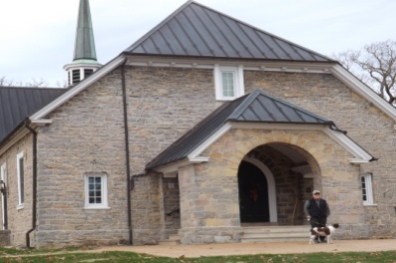
From this hardy stock arose our families. And out of them arose: some of the signers of the Declaration of Independence, authors of the U.S. Constitution, writers, lawyers, doctors, educators, builders, civil servants, tradesmen, adventurers, pastors, mechanics, industrial scions, cattlemen, nurses, ranchers, cowboys, storekeepers, presidents, governors, congressmen, senators, warriors, artists, soldiers, generals, explorers and you and me. As medicine had been blessed by Bells in Scotland, medicine was blessed by Bells in America. North American education institutions have been blessed by Bells and other Scots, who have long held education in high esteem. Though faith was not often always evident or at the center of those oft-ugly times on the Borders, Bells’ faith helped build the churches in many a locale all across North America; the Augusta Stone Meeting and Tinkling Spring Church in the Shenandoah Valley celebrated their 275th Anniversary in 2015. It is said that William Bell (1685-1757), my 5th great grandfather, was the stonemason of the Augusta Stone Meeting. Augusta Stone Meeting was built as a stone fort and Covenanter church combined, reflecting strength, safety, hope and faith to all in those early times. These are of whom we proudly descend!

